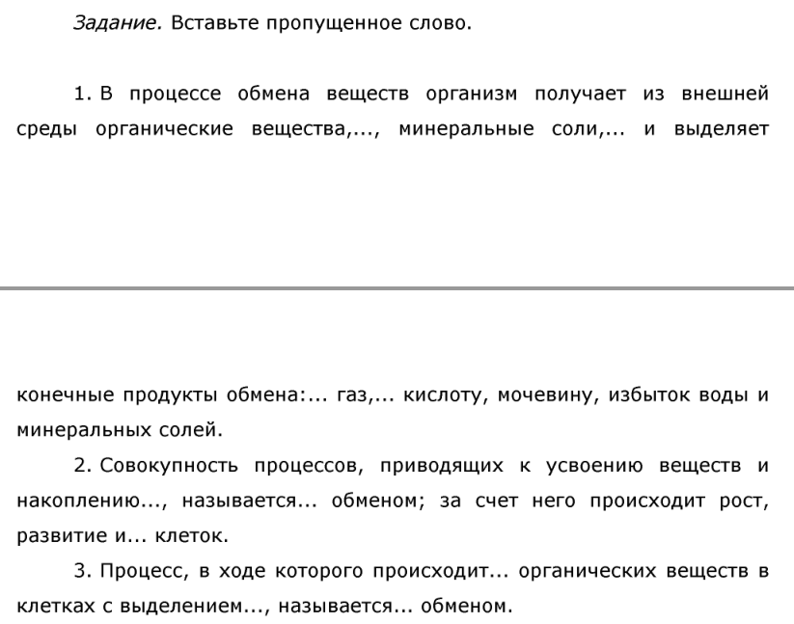

|  |  |  |  |  |
| --- | --- | --- | --- | --- |
| **1.** | 1) | 2) | 3) | 4) |
|  |  |  |  |  |
| **2.** | 1) | 2) | 3) |  |
|  |  |  |  |  |
| **3.** | 1) | 2) | 3) |  |
|  |  |  |  |  |

